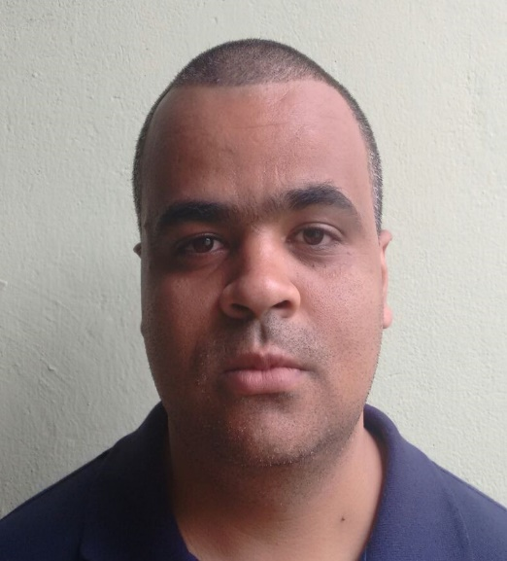
Marcos Papa
Front-End free lancer

About me
Front-End developer graduated in Technology in Systems Analysis and Development by UNIFRAN. Technician in Business Management by SENAC-MG. I took several preparatory and professional improvement courses through UDEMY, ORIGAMID, CFB Cursos and Curso em Vídeo.

ContACT
370 Domingos Vaz de Oliveira Street, Araxá, MG 38181-549, Brazil
+55 34 98884-7402
marcos_papa@hotmail.com

Projects
GHOSTBUSTERS The project is a fictional service page of the company GHOSTBUSTER. It was created based on a layout provided by w3schools in order to practice and demonstrate my knowledge in HTML, CSS and JS. Can be accessed at: https://chipper-mooncake-77b378.netlify.app/

NUBANK COPY A copy of the NUBANK website. Responsive website created to demonstrate and practice my knowledge in the front-end area. It can be accessed at: https://marcosamanciopapa.github.io/nuCopy/

Responsive Modal A modal that adapts to various screen types. Created to practice the concept of responsiveness. It can be accessed at: https://marcosamanciopapa.github.io/modalResponsivo/

EDUCATION

2016 - 2018 Technology in System Analysis and Development
Universidade de Franca

2008 – 2010 Technician in Business Management
SENAC-MG

COURSES
JavaScript from Beginner to Master
UDEMY

Complete web development course
UDEMY

HTML5, CSS and JavaScript in practice
UDEMY

Graphic Design and UI/UX
UDEMY

